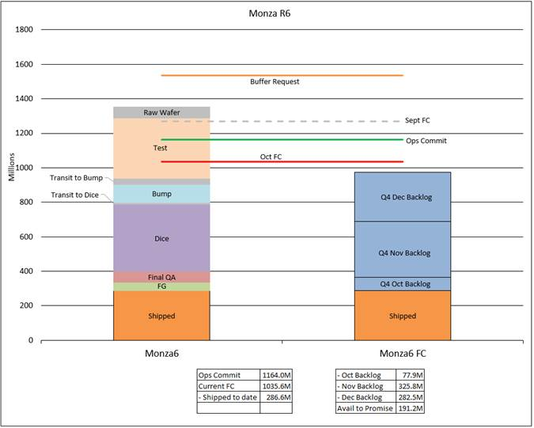

Above is excel pic.
Second one is spotfire:
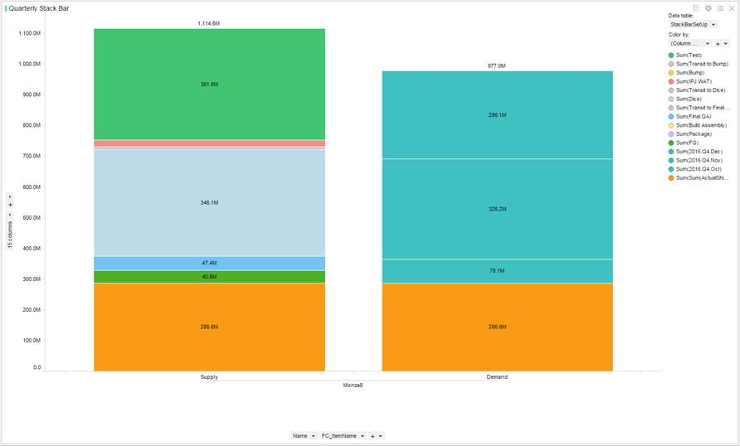

Would like see , Test, Dice on the labels of the chart instead of its value.

