As an example, I am using images of animals to re-create my problem (real-world problem involves wells, and dynamically displaying an image from the network where the filename is based on the well ID). I would like the images to display in my table and reflect the latest files.
Originally followed: https://docs.tibco.com/pub/spotfire/6.5.0/doc/html/table/table_images_in_tables.htm
Example images in folder that I wish to display in the Spotfire report:
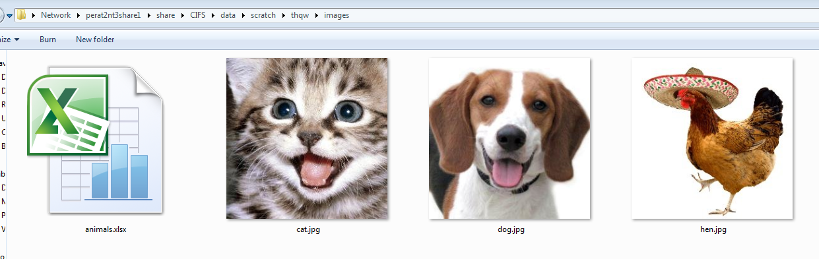
Example base data in animals.xlsx
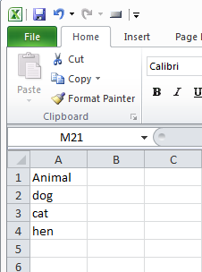
Create a new Spotfire report from this Excel spreadsheet:
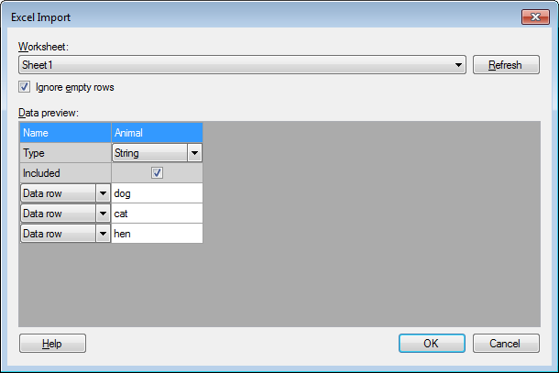
Create new Table visualisation:
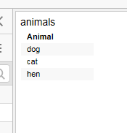

Change rendering Properties to render as an image from an URL:
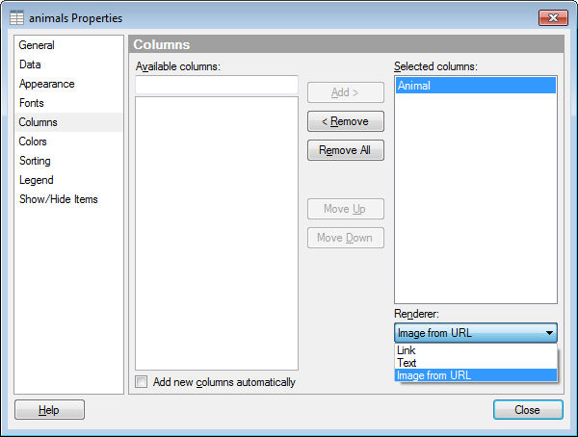

Enter path from above to the directory with images:
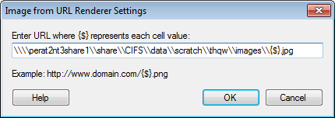
Table visualisation with correct images displayed:


Updated underlying cat.jpg – the cat now has glasses:
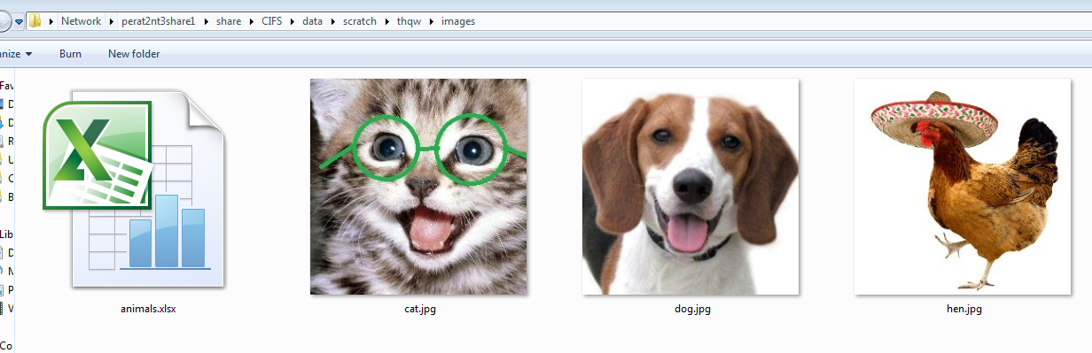

Image displayed in table visualisation does not update. Previous version appears to be cached. How can I get this image in the visualisation to reflect the current file? I have attempted…
- Refreshing Data Source
- Save, close report, open report
- Save, close Spotfire, open Spotfire and report
None of these appear to update the visualisation with the updated image file

