Before:
No selection on Target Percent, the color rules applied based on 100%, the former percentage, as the indicator
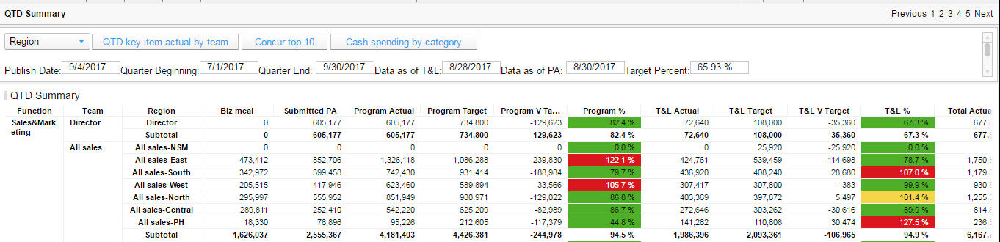

After:
Selection on Target Percent, no other actions, the color rules refreshed and alert changed
