Right click on the plus icon to add the new bookmark and select Add bookmark special
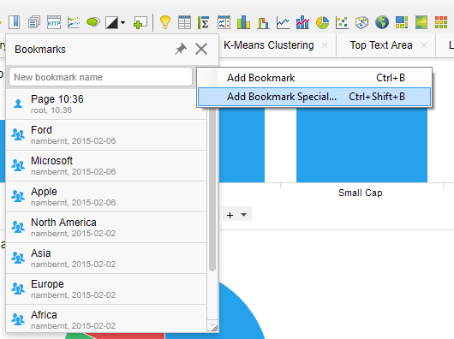
Then Select the aspects you want to capture in the bookmark.
