Labels can be added to a Bar Chart Visualisation

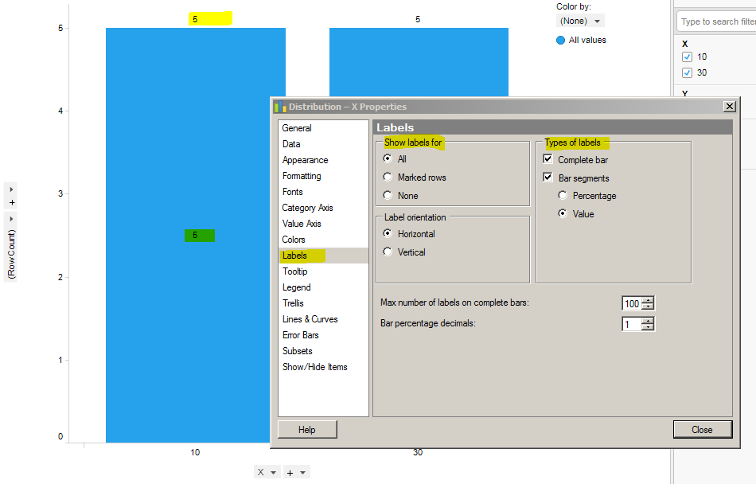
This is not currently possible in a Tresslis Card Visualisation Bar Chart (D below):

