- Open the attached template and Add a New Property manually for column A
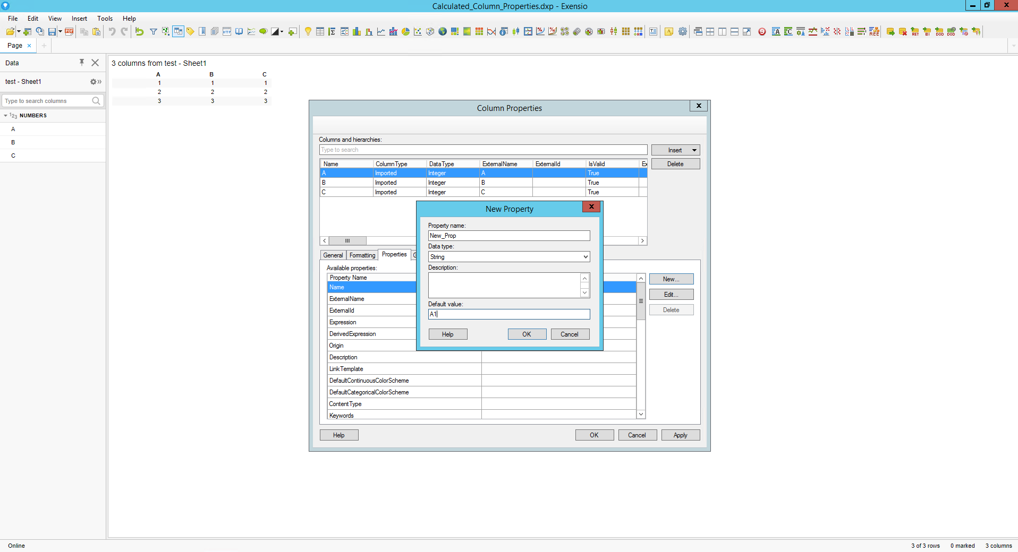

A,B,C columns will take the same New Property values as you provided ‘A1’

- Use this python script to change the B column New Property value to ‘B1’:
table_target = Document.Data.Tables['test - Sheet1']
target_Calculated_Column = table_target.Columns.Item['B']
target_Calculated_Column.Properties.SetProperty('NewProp', "B1")

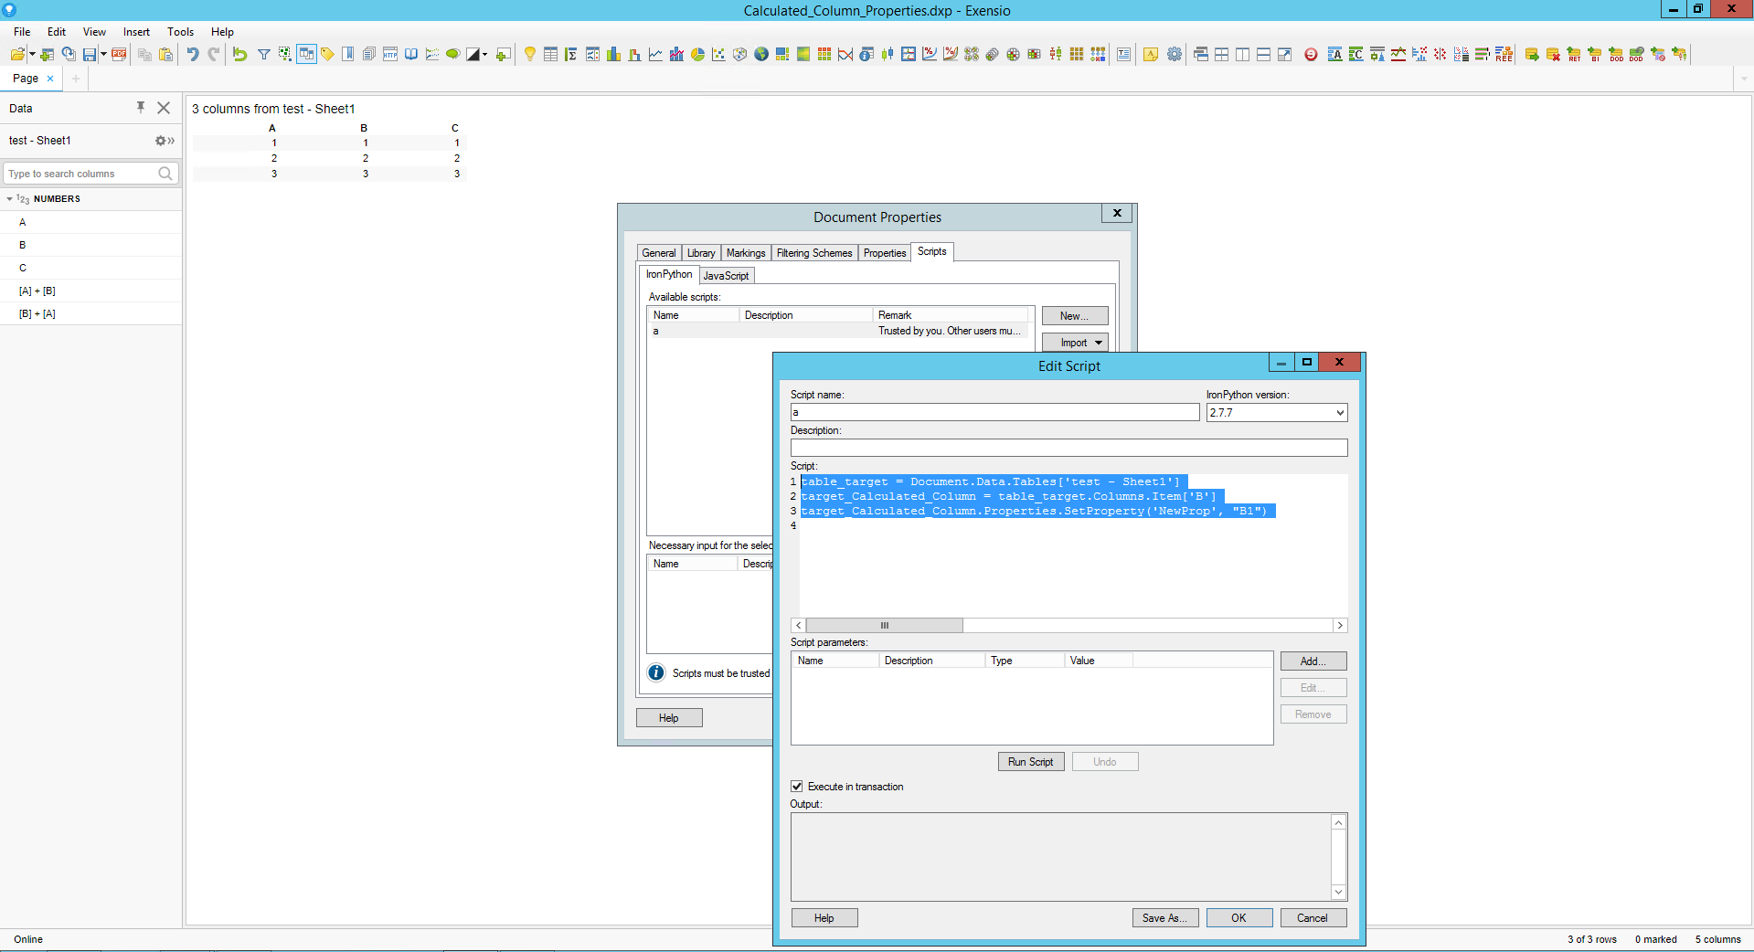

- Insert calculated column with adding A and B columns -> [A] + [B]
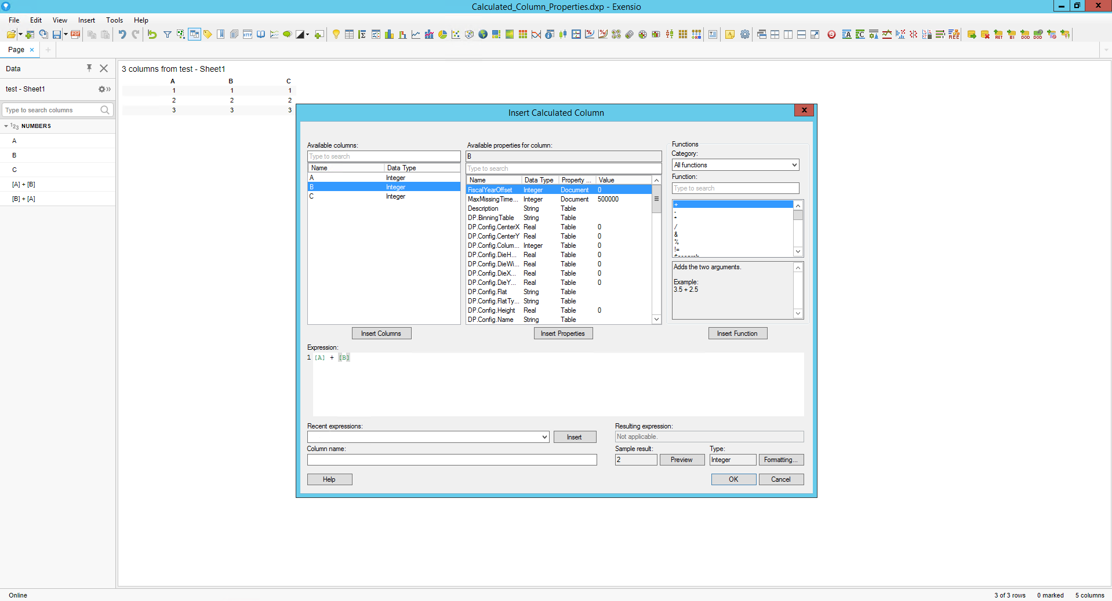

- Insert another calculated column while swapping the A and B columns
in the expression -> [B] + [A]

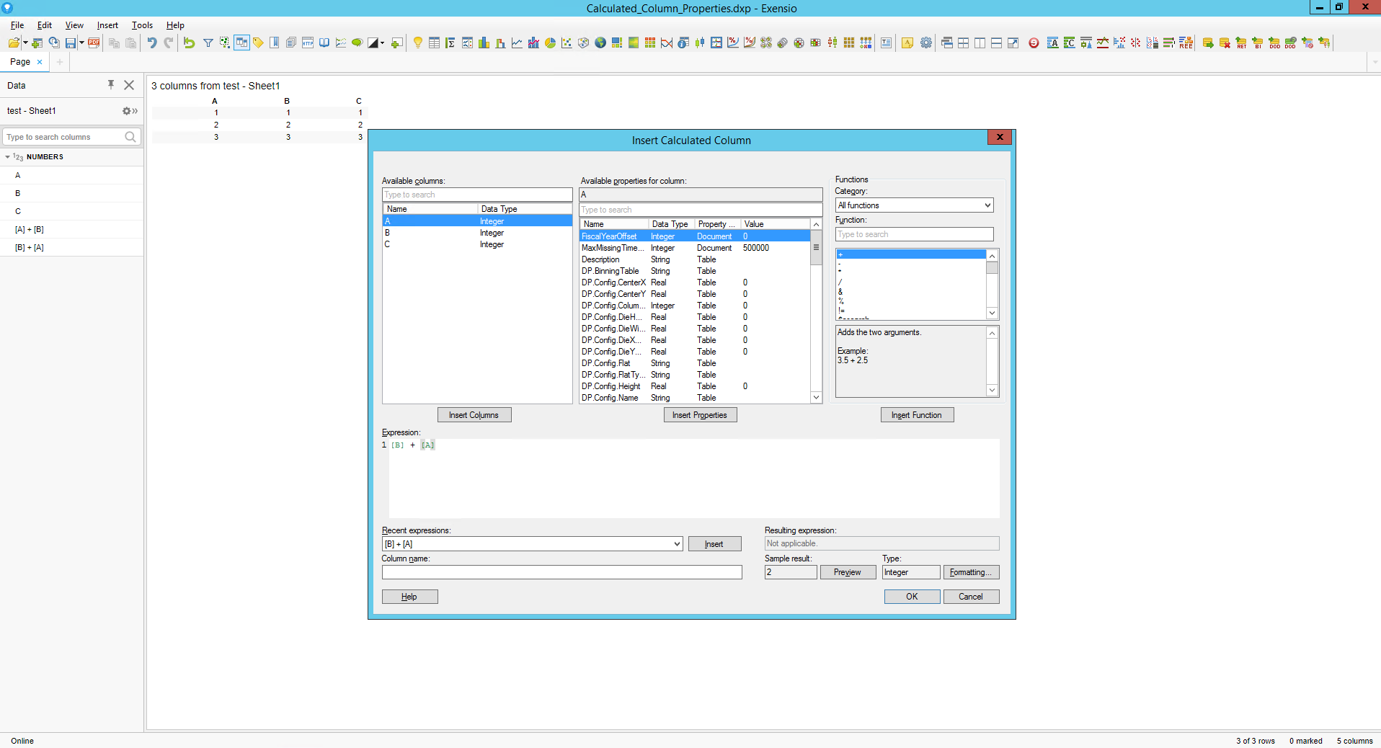

- Check the Resulted columns properties
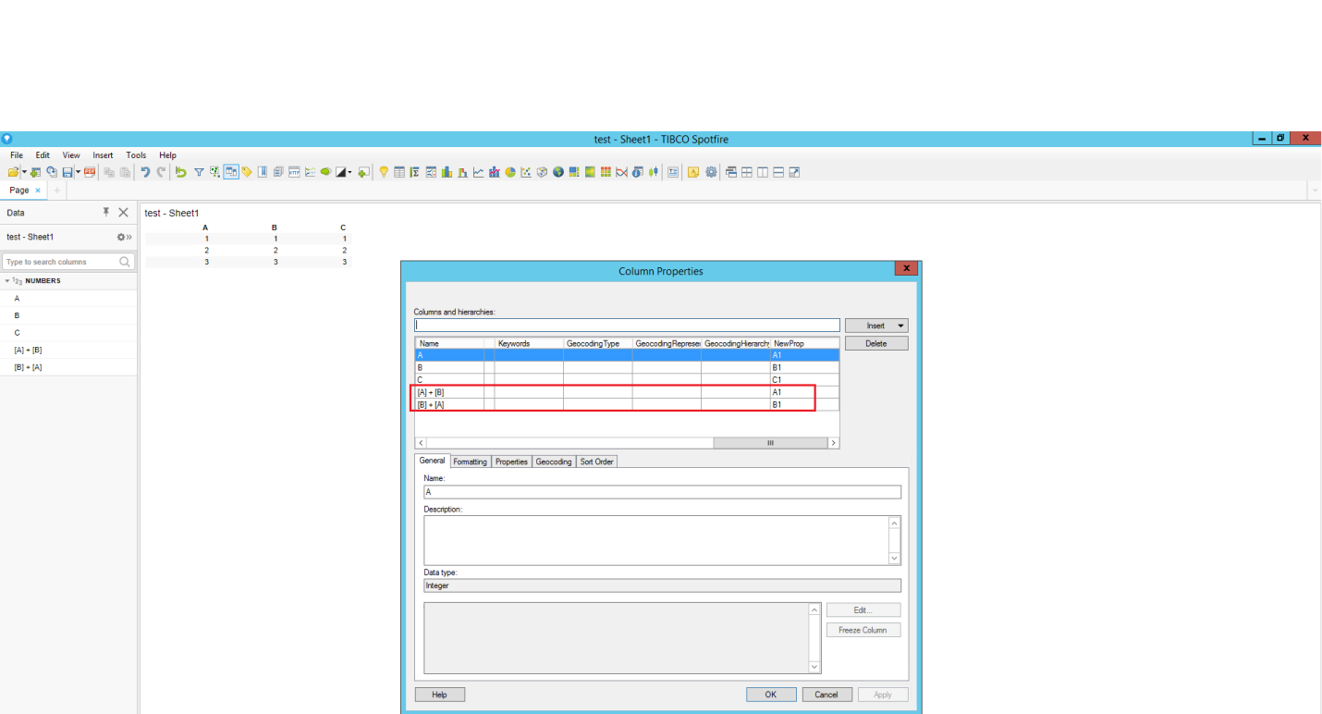

These steps are to make sure that this behavior is also meant by spotfire provided default properties for columns.

