Requirement 1:
Y axis scale
I want multiple curves on the left Y axis share the same scale while other curves on the right Y axis share another same scale.
Spotfire allows all curves I different scales or a same scale:
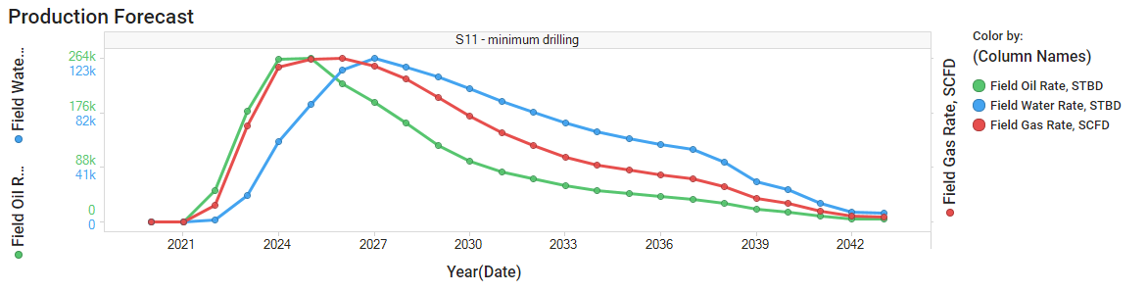
The water rate cannot be compared with the oil rate since they are in different scale. The gas rate should still be in different scale.
What we want:
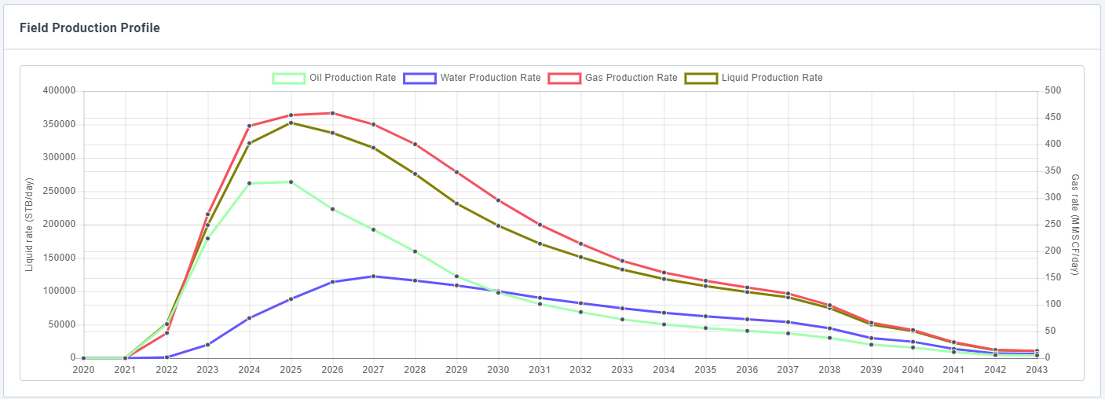
Clarification: The need is to have some shared y-axis scales and some not shared – for auto-scaling, need to specify which measures share a scale.

