Requirements to be discussed with TIBCO Product Managers
Requirement 1:
Y axis scale
I want multiple curves on the left Y axis share the same scale while other curves on the right Y axis share another same scale.
Spotfire allows all curves I different scales or a same scale:
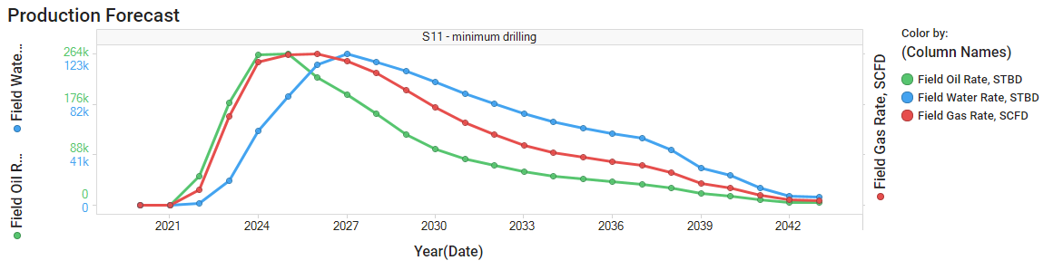
The water rate cannot be compared with the oil rate since they are in different scale. The gas rate should still be in different scale.
What we want:
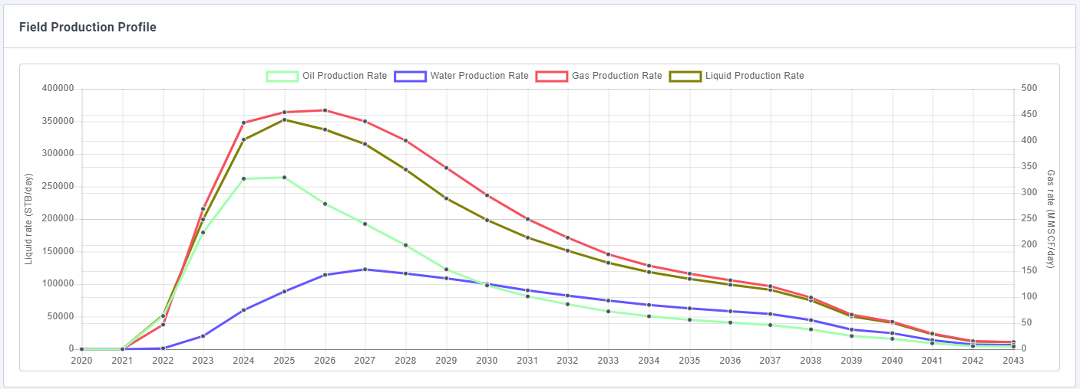
Clarification: The need is to have some shared y-axis scales and some not shared – for auto-scaling, need to specify which measures share a scale.
Requirement 2:

- Uncertainty Workflows: ability to shade he uncertainty bands (p10, p50, p90 for example)

This is what is looks like in Spotfire; each solid line represents p10, p50 and p90. Ideally, we would like to shade each section below the lines accordingly.

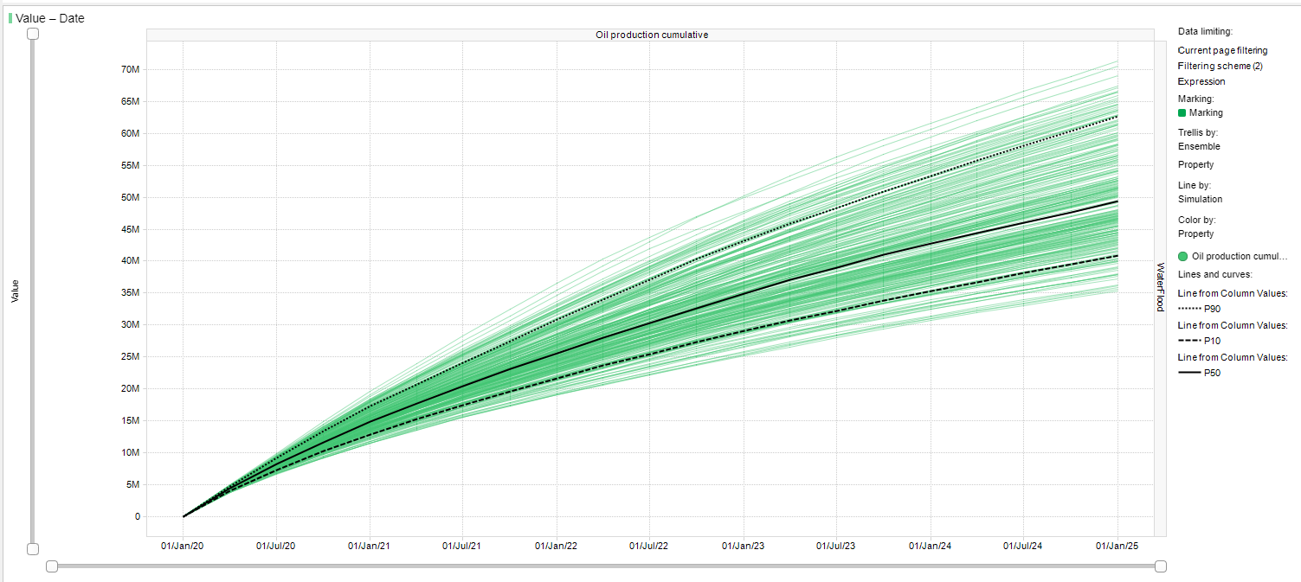
Like so:

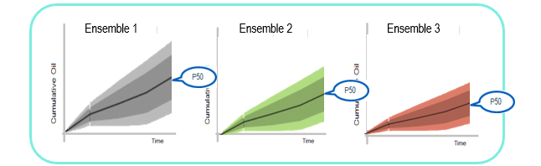

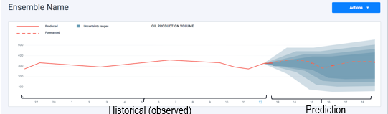
Angular example
Need to talk to TIBCO – P1 for RE

Requirement 3:
Need to be able to get list of data values when data has been filtered in a visualization, as can be done when values are marked. Reference support case 1732111.
The requirement for this results from using a Spotfire visualization with another application:
- The user is displaying two applications side by side with related sources of data (a common key or filter value), containing even values from 2 to 100 (2, 4, 6, . . . , 98, 100).
- The user applies a filter on the Spotfire visualization to only display values 80-94 (80, 82, . . . 92, 94).
- There needs to be a way to obtain the values in the Spotfire visualization to pass them in the javascript api to the other application.

Requirement 4:
When a filter is applied using the javascript api, the request fails if one or more of the values specified in the filter is not present in the Spotfire data source. Reference support case 1732181.

Let’s imagine that we have 2 data sources, they have info about some items with columns: id, type and etc.

Data source 1 contains next ids: 1,2,3,4,5,6 – my data source (3d party app)

Data source 2 contains next ids: 3, 4, 5, 7, 8, 9 – data source that Tibco Spotfire used.

set1 set2

{1,2,3,4,5,6} and (3,4,5,7,8,9)

{ 1, 2, ( 3, 4, 5} 7, 8, 9)

both sets contain only 3,4,5 in common

When I try to filter data

• 1 scenario (ListBox Filters):

let filterColumn = {

dataColumnName: ‘id’,

dataTableName: ‘dataTableName’,

filteringSchemeName: ‘Filtering scheme’,

filterSettings: {

values: [3, 4, 5]

},

filterType: LIST_BOX_FILTER

}

this.spotFireApp.analysisDocuments[0].filtering.setFilter(filterColumn, spotfire.webPlayer.filteringOperation.REPLACE); (link to JS API)

As a result: it works, and on a screen I have only data with ids 3, 4, 5

• 2 scenario (ListBox Filters):

let filterColumn = {

dataColumnName: ‘id’,

dataTableName: ‘dataTableName’,

filteringSchemeName: ‘Filtering scheme’,

filterSettings: {

values: [1, 2, 3, 4, 5]

},

filterType: LIST_BOX_FILTER

}

this.spotFireApp.analysisDocuments[0].filtering.setFilter(filterColumn, spotfire.webPlayer.filteringOperation.REPLACE); (link to JS API)

As a result: it doesn’t work, and nothing change on a screen, looks like because I try to filter by some id that does not present in TIBCO Spotfire datasource.

