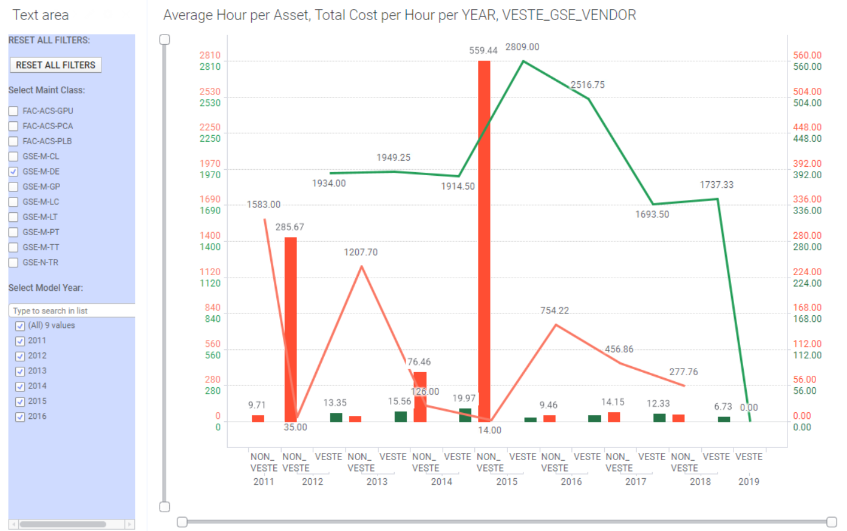
GSE-M-DE (DEICER) -> VESTER VENDOR VRS. OTHERS

Notice the year 2014 bars chart arrowed above. They belong to the year 2014 and should have been side by side each other. Thus, if one does not look very carefully, a mistaken interpretation could be the result, and this is what I referenced in the idea.
Thanks.
McGeoffrey

