This arrowed label 2809.00 should have been green colored to match the curve.

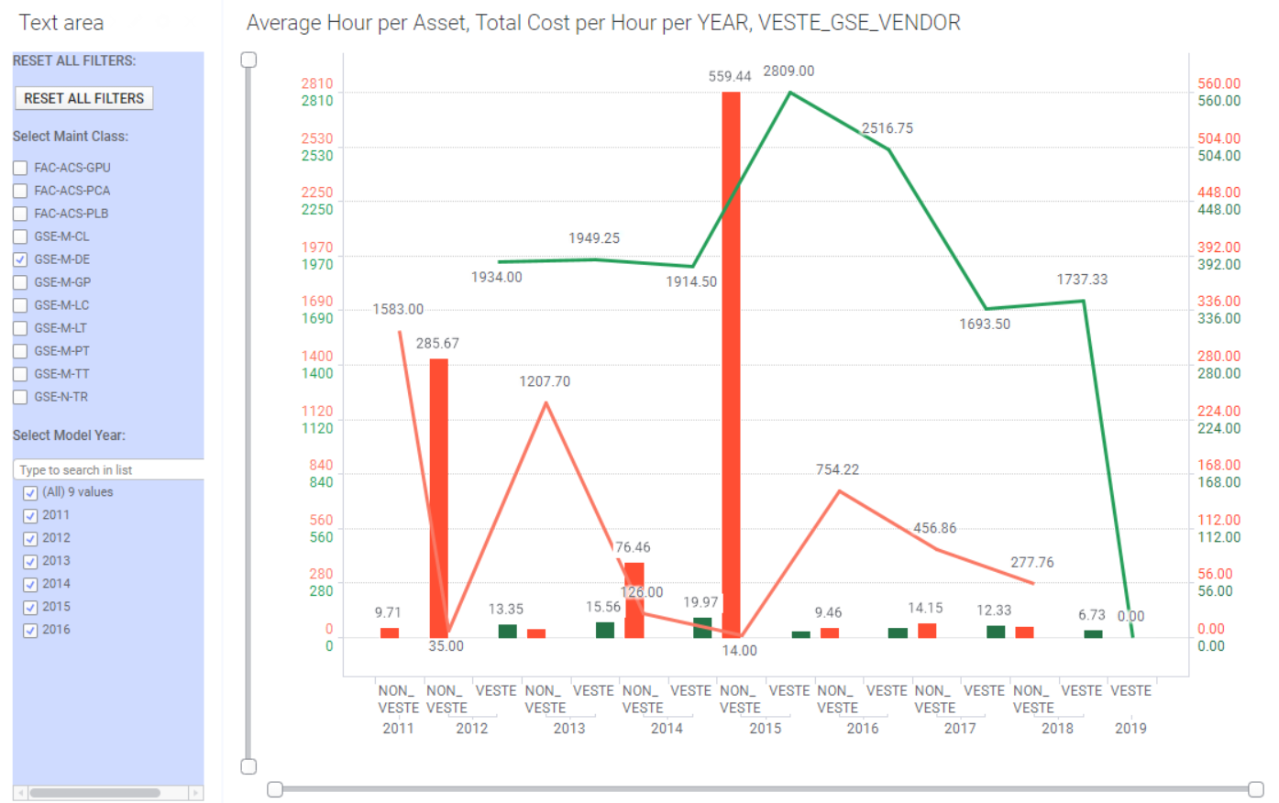

- The scales on the side shouldn’t necessarily need to be duplicated below each other.
So, I allow the user to be able to assign multiple curves to a scale.
- All labels or dimensions with the bars and curves curve green colored curve should have been green. Similarly, all the red curves and bars should have been red as well.
Thanks.
McGeoffrey

