SPOTFIRE-We need no line and need the dots on the bars. Is this possible? Want it to look similar to the tableau example at the very bottom.
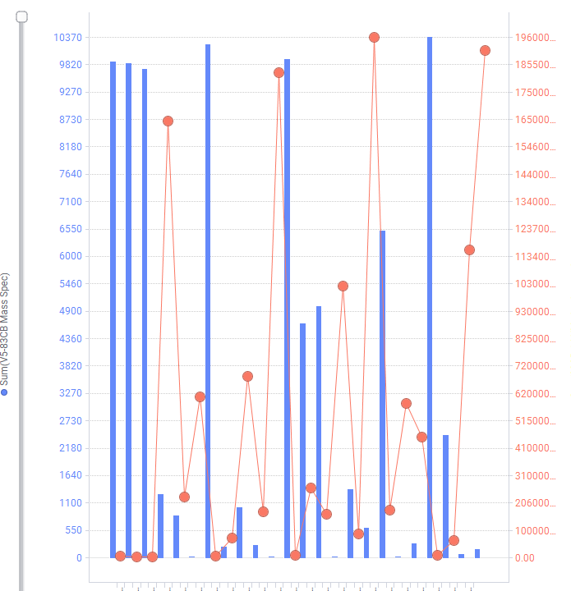

Tableau – Dual axis with dots on the bars with no line. Is this possible in Spotfire?
