Hi Niklas,
I've done some further testing on this.
I have an existing dxp file with multiple data tables. When I open the filter panel there are filters from multiple data tables visible, but the data table names are not displayed at all and so I can't select the hide data table option.
On further investigation, only one of the data tables (Sales2) is set to "Show in User Interface" in the data table properties. This appears to be why the data table names are not being displayed, however there are still columns from the hidden data tables displayed in the filter panel.
See below for screenshots and further explanation.
When initially opened – the filter panel shows no data table names, although the filters shown are from multiple data tables:
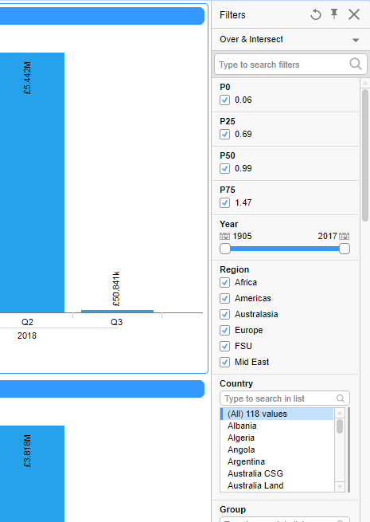

On opening the Organise data table view you can see that the filters displayed are from multiple tables – for example the columns P0, P25,P50 and P75 are coming from the Quartile Factors table:
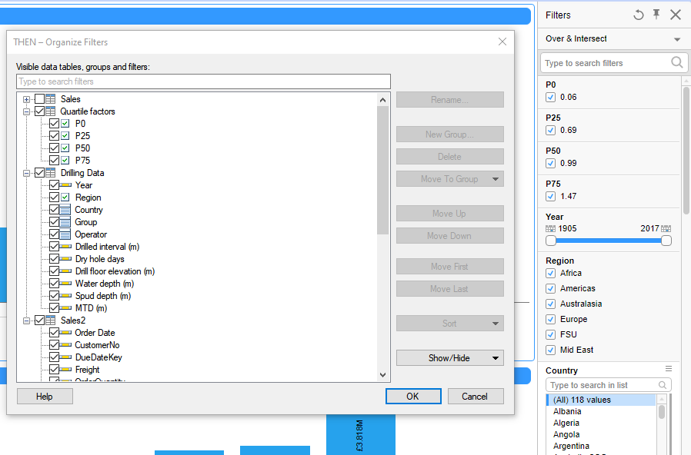

Looking at the Data Table properties, I find that only 1 table (Sales2) is set to ”Show in User Interface” and the Quartile Factors table is hidden:
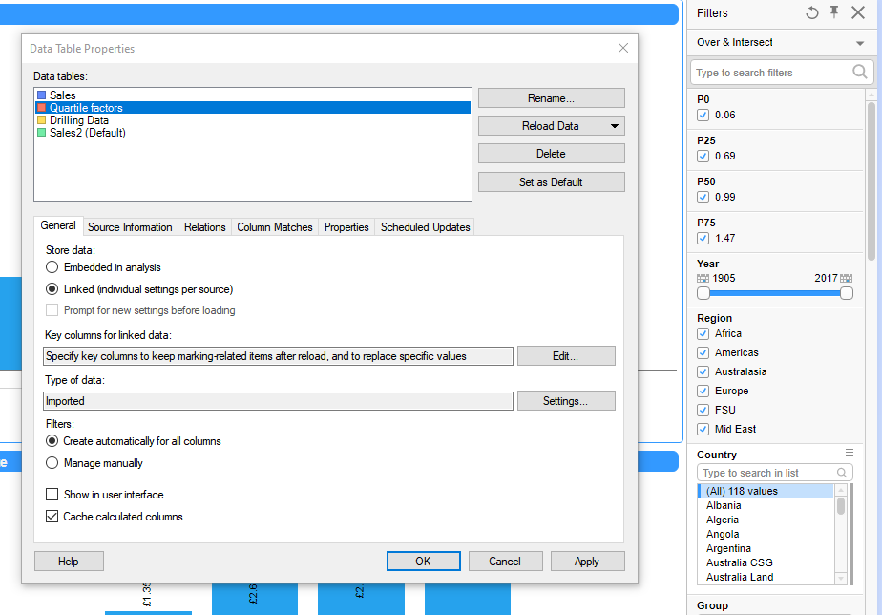

Marking Quartile Factors table as “Show in User Interface” and clicking OK still leaves the filter panel without Data Table names, but then making any change to the filter panel using Organise Filters causes the data table names to reappear:
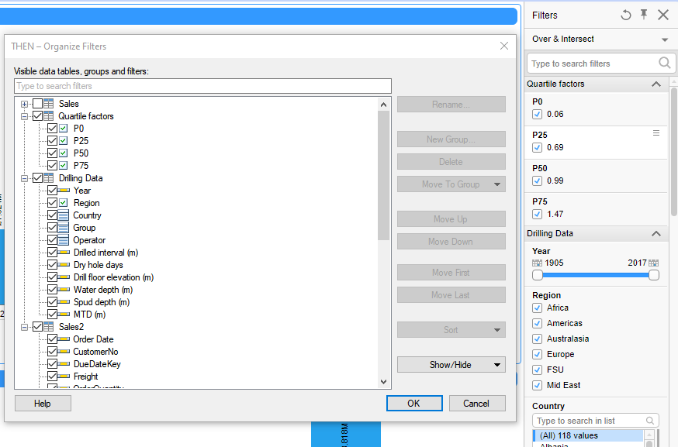

So this appears to be a bug, although in a way it's related to an idea I posted yesterday - TS-I-7851 about hiding columns from hidden data tables by default when creating a new data table

Hope this helps!
Steve

