Currently this is what I am doing with my Trellis:

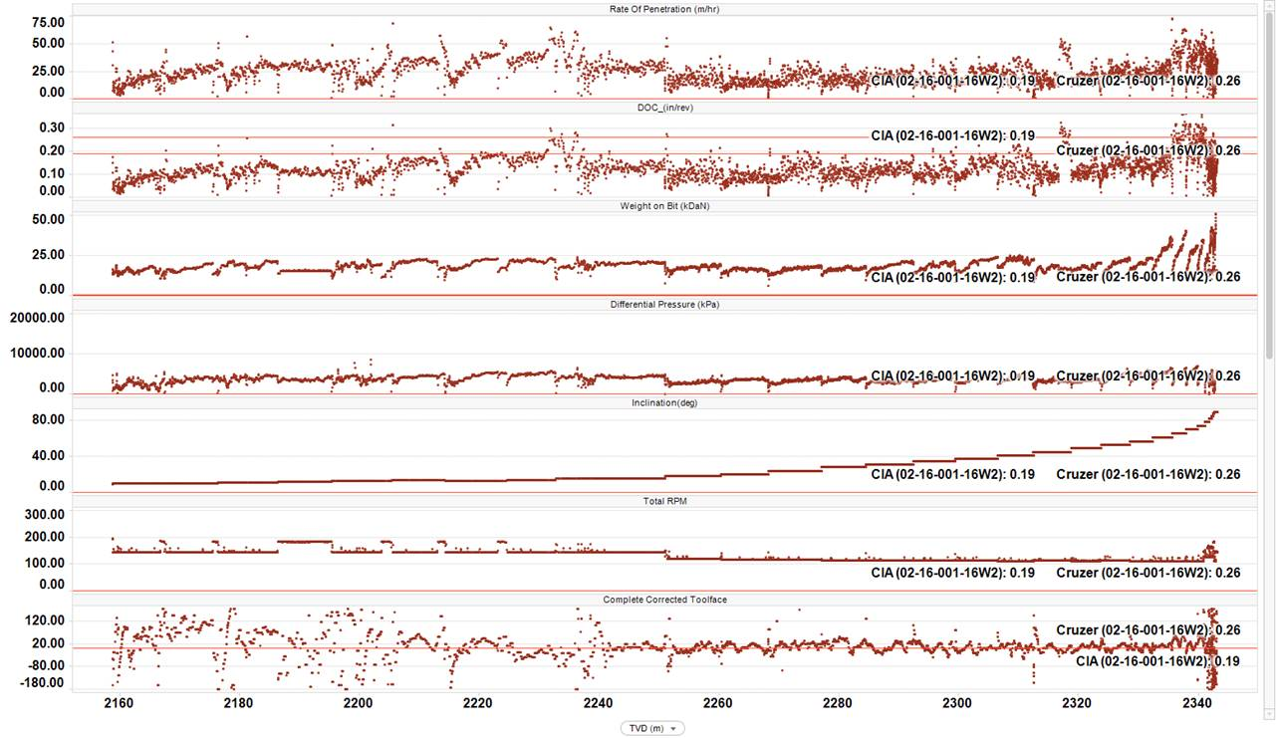

I need to do the same with Trellis as the below. Below is 6 different charts next to eachother. I can’t seem to find a way to turn it into a trellis keeping the below x-axis for the individual charts and the same y-axis for all the charts:

